# **Overview**

Ever wondered how much you know about your car and how it works on the inside? Let Drvr take you through an immersive learning experience to further develop your knowledge on the four wheel automobile you have been or will be driving!

Drvr’s three components will take you on a drive on the learning lane, allowing you to experience informative infographics, interactive systems simulation and challenging quizzes to enhance your understanding on how a car works.

# **Objectives**

Drvr has the following objectives:

* To produce informed users by polishing/improving their knowledge on cars
* To allow users to understand how the components in the car interact.
* To allow users to put the knowledge they have acquired to test.

# **Installation**

* Run the setup file that comes with this manual.
* [Include images to allow user to follow instructions]

# **Introducing Drvr**

[Insert Drvr main menu here]

## **Infographics**

Choosing the Infographics option from the main menu will bring you to a screen as shown in figure 1. The infographics will allow you to learn about parts of the car through brief descriptions, images and video links.

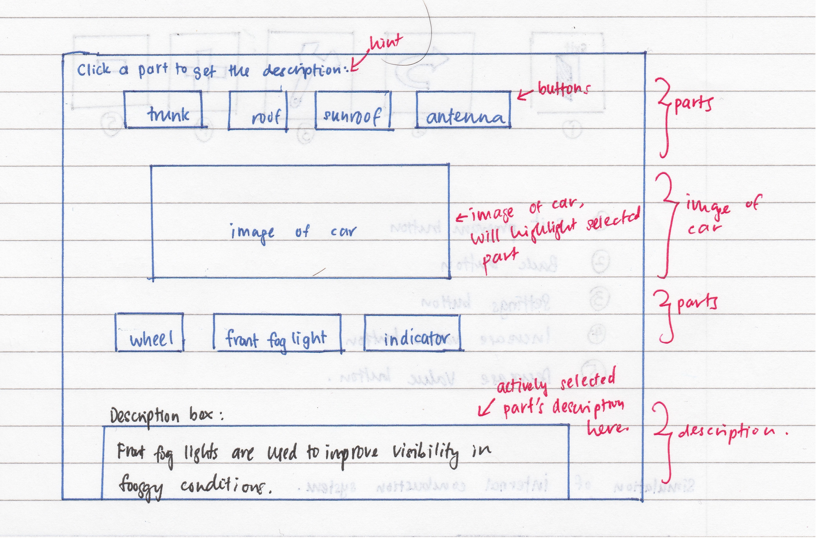

Figure 1: Infographics main screen

### VIEW

* You will be able to see different parts and views of the car by clicking on either the left or right arrow that cycles through the ‘Front’, ‘Rear’, ‘Side’, ‘Bottom’ and ‘Interior’ view of the car.

### COMPONENTS LIST

* You will be able to select any component listed in this list to learn more about it. Description of the part can be found in the description box below the image.
* The selected part will also be highlighted on the image of the car.

### DESCRIPTION BOX

* The description of the selected part will be appear here.

### HOME

* This button will bring you back to the main menu.

## **Simulation**

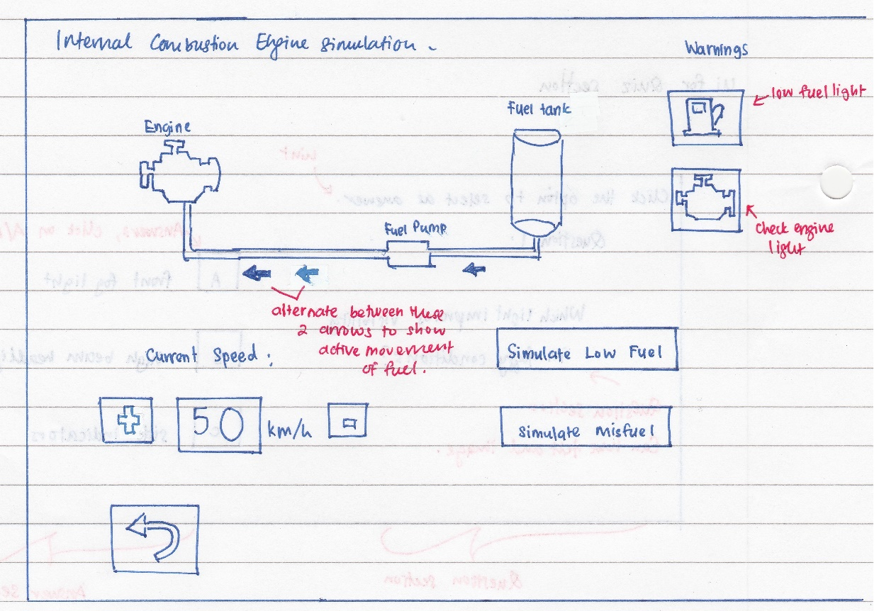

Figure 2: An internal combustion engine simulation under ‘Simulation’

## **Quiz**

The quiz segment will test you on how well you have understood the car systems from the infographics and simulation part.

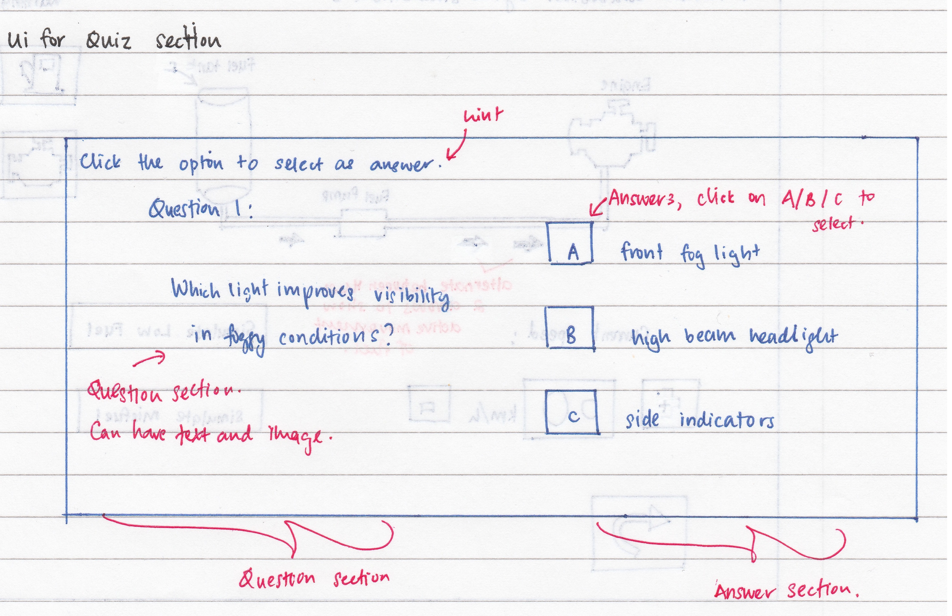

You will be able to take on the quiz at either ‘basic’ or ‘advanced’ level.

Figure 3: An example of the quiz question

* A series of questions will be provided to you and you will be required to answer them within [X amount of time].
* The segment on the left will be where the question will be while the segment on the right will be where the answers are, as shown in Figure 3.
* Questions can be in the form of text or image and you will be required to select the most befitting answer from the answer section.
* Select your answer and click on ‘Submit’ to proceed to the next question. A window will appear to confirm whether or not you wish to submit the answer that you have chosen. [WARNING: Selecting ‘YES’ here will not allow you to change the answer which you have submitted].
* Once all questions have been answered, your results will be shown at the end of the quiz.

[Insert end page image]

* You are able to review the questions that you have answered to find out which ones you have gotten right or wrong.
* When reviewing an incorrect question, answers highlighted in [colour] are the answers you have chosen while those highlighted in [colour] are the correct ones.
* Answers are highlighted [colour] when reviewing questions you have answered correctly.